Recently, Warren and his colleague Richard Wilson, also at Washington University, put together a team of 102 scientists to study the platypus genome. A genome is an individual blueprint, like a map or a plan, for a creature. An organism's genome has all its hereditary information. And that information is encoded, like a secret message, in a long molecule called DNA.
Scientists from universities and research institutes all over the world worked on this platypus genome project. Warren and Wilson split the DNA decoding among a number of specialized groups.
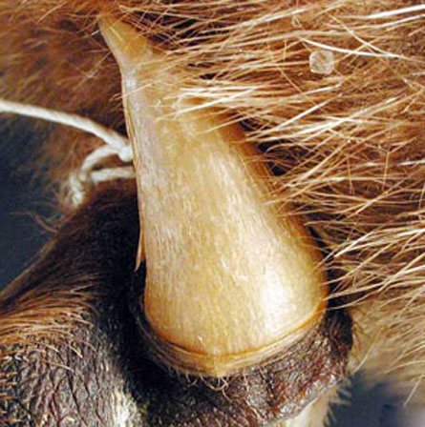
Like reptiles, platypuses lay eggs and make poison. Spurs on the hind feet of platypuses deliver the toxin when the mammals feel threatened.
stowe boyd / flickr
One group studied fragments of DNA that move around within the genome of a single cell. Another group examined very short fragments of DNA that repeat themselves. Another studied active portions of the genome, those parts that code for a message, while yet another group studied the inactive portions of the genome. All of these groups have multiple scientists, so the project is made up of a lot of scientists.
With so many scientists cooperating, you might think they'd produce an encyclopedia of knowledge. But examining the genome of one animal, even one as odd as the platypus, doesn't tell you very much. Eric Lander at the Broad Institute in Cambridge, Mass., explained it this way: "If you really

